PATIENT’S NAME: _____________________

MedVed Integrative Medicine and Acupuncture Clinic

10951 SORRENTO VALLEY RD 1-d san diego ca 92121 phone: 619-354-0455

Acupuncture • auricular acupuncture • Cuppung/ massage • REIKI • electric acupuncture • herbs • IASTM • TUI NA

New Patient Intake Form
Date ____________________ Referred by ______________________________________________ Name ________________________________________ Date of birth _____________ Age _____
Height _______________ Weight ________________ Occupation ___________________________ Address __________________________________________________________________________
E-mail Address _____________________________________________________________________ Telephone: Home ( ) _________/__________ Work ( ) ____________ /______________
EMERGENCY CONTACT: In case of an emergency, please contact:
Name:____________________________________ Phone # ( )___________/________________ Address:____________________________________________ Relationship: _____________________
Primary Physician:____________________________________ Phone # ( )_______/____________ Address:_____________________________________________________________________________

PERSONAL HEALTH HISTORY
CHIEF COMPLAINT: _____________________________________________________________________
How long have you had this health concern? ________________________________________________
Is there any time of day or night in which your condition is worse? _______________________________
_____________________________________________________________________________________
What makes your condition better? (rest, heat, ice, etc.) _______________________________________
_____________________________________________________________________________________
What makes your health concern worse? (exercising, certain movements, heat, cold etc.) ____________
_____________________________________________________________________________________
What other forms of treatment have you sought for this condition, when did you have these treatments, and were they helpful? __________________________________________________________________
PATIENT’S NAME: _____________________
Please describe the condition in detail: __________________________________________________ __________________________________________________________________________________
__________________________________________________________________________________
__________________________________________________________________________________
Secondary Complaints _______________________________________________________________
__________________________________________________________________________________
Have you ever been hospitalized? ____________ If yes, please describe: _______________________ __________________________________________________________________________________
Have you received acupuncture before? _______________ If Yes, when? ______________________
With Whom? _______________________________________________________________________
Please indicate if you have any significant illnesses:
 Cancer  Diabetes  Hepatitis  Herpes  Hernia  Heart Disease
 Hypertension  Seizures/Epilepsy  Stroke  Arteriosclerosis Varicose veins  Sleep apnea  Asthma   HIV  Blood clotting disorder  Emotional Disorders   Infectious Diseases  Tuberculosis  Osteoporosis  Sexually Transmitted Diseases
Other: _____________________________________________________________________________
Any Drug allergies?  Yes  No
If Yes, please explain: ________________________________________________________________
Please indicate any significant illnesses your blood relative (grandparent, parent or sibling) have had:  Cancer  Diabetes  Hepatitis  Heart Disease  High Blood Pressure  Seizures/Epilepsy  Stroke  Heart attack  Emotional Disorders  Addictions
 Mental health problems
Do you have any prosthetic devices, pacemakers, metal pins, etc. in your body?
  Yes   No Explain:_______________________
List any medications and supplements you are currently taking: (Continue on back if necessary.) Medicine Dosage Reason How Long Prescribed by
_________________ ____________ _______________ ______________ ________________
_________________ ____________ _______________ ______________ ________________
_________________ ____________ _______________ ______________ ________________
_________________ ____________ _______________ ______________ ________________
Supplements: _________________________________________________________________________
PATIENT’S NAME: _____________________
Diet/lifestyle:
Coffee/Black Tea  Yes   No How Much?_____________________
Tobacco  Yes  No How Much?_____________________
Water Intake ________________ How Much?_____________________
Recreational Drugs Yes No _________________________________________________________
Alcohol  Yes  No How Much?_____________________
Soda/Pepsi  Yes   No How Much?_____________________
Fast Food  Yes  No How Much?_____________________
Frozen/pre-processed food  Yes  No How Much?_____________________
Do you exercise regularly?  Yes  No  Weight loss  Weight gain
What kind and how much? ______________________________________________________________
List any allergies, food sensitivities: ________________________________________________________
What are your hobbies/things you enjoy doing in your free time? _______________________________ _____________________________________________________________________________________How do you feel about the following areas of your life?
Spouse or Significant Other Great Good Fair Poor
Friends Great Good Fair Poor
Career Great Good Fair Poor
Quality of Life Great Good Fair Poor
Sex (optional) Great Good Fair Poor

FEELING OF COLD AND HEAT
  Fever   Chills    Hot   Cold   Feeling heat in afternoon or evening   Hot flashes
 Shivers Other ______________________________________________________________________
I prefer:  Hot weather   Cold weather Usually I am:  Hot at night  Cold at night
I feel cold in my:  Back  Abdomen  Fingers  Hands  Feet  Knees  Legs

SWEATING
 Spontaneous sweating  Day sweats  Night sweats    Sweating on exertion
 On forehead  On palms   On feet  On arms and legs  Whole body
PATIENT’S NAME: _____________________
HEADACHES
 Dull pain  Sharp pain  Distending/Throbbing  With heaviness  With dizziness Aggravated by: ______________________________ Relieved by: _______________________________
Location:  Nape of the neck  Forehead  Temples, sides  Vertex  Whole head
 Day time pain  Evening pain  Night time pain
FACE AND HEAD
 Dizziness  Facial pain  Bleeding gums  Loose teeth
 Swollen and painful gums  Mouth ulcers  Tongue ulcers  Dry mouth  Bad breath
 Bitter taste in the mouth  Sweet taste  Salty taste  Metal taste  No taste
 Ear ringing- high pitch sound  Ear ringing- low pitch  Poor hearing
 Dry eyes Itchy eyes  Red eyes  Blurry vision  Eye floaters  Night blindness
 My vision has changed suddenly: _______________________________________________________
 Swelling of face and eyes  Stuffy nose  Runny nose   Dry nose  Nosebleeds
 Sneezing  Sinus problems  Loss of smell  Sore throat  Dry throat  Cough
 Propensity to catching colds
 Rattling sound in the throat  Feeling of a lump in the throat
SLEEP
How much do you sleep? (Hr/night) __________ Do you feel rested in the morning?________________
 Restless sleep  Dreams Insomnia  Hard to fall asleep  Hard to stay asleep
 Waking up often  Waking up early and failing to fall asleep
ENERGY
 High  Low  Tiredness  Difficulty concentrating
PSYCHOLOGICAL
 Depression Irritability  Fear  Worry/Overthinking  Sadness  Anxiety
 Short temper  Anger  Feeling agitated  Impulsiveness  Mental confusion
 Moodiness  Frequent sighing  Inability to speak  Lethargy  Suicidal thoughts
 Lack of courage  Lack of initiative  Timidity  Panic attacks
 Poor short term memory  Poor long term memory
PATIENT’S NAME: _____________________
SKIN, NAILS
 Dry skin  Itchy skin  Sensitive skin  Oily skin  Eczema  Psoriasis
 Rashes  Hives  Slow wound healing
 Brittle hairs  Dry skull  Hairs falling out  Split, brittle nails
FOOD AND DRINK
Do you follow any diet? ________________________________________________________________
Do you eat:  breakfast  lunch  dinner (what time? _________  snacks
Any midnight snacks? __________________________________________
Any food cravings? _____________________________________________________________________
I have:  Good appetite  Poor appetite  Always hungry  Bulimia  Anorexia
 Fullness and distention after eating  Preference for hot food  Preference for cold food
 Nausea  Vomiting  Belching  Acid regurgitation  Stomach Pains
 Poor appetite  Noisy Stomach  Difficulty swallowing  Vomiting blood
 Abdominal pain  Masses in the abdomen  Constipation  Loose stool  Diarrhea
 Blood in the stool  Alternation of constipation & diarrhea  Difficulty digesting fats  Thirst
BODY
 Convulsions  Neck and shoulder pain  Neck stiffness  Back pain  Bell’s palsy  Paralysis  Flaccidity  Rigidity  Paralysis  Contractions  Tremors
 Spasticity  Numbness or tingling of limbs  Muscle weakness  Muscle spasms  Muscle cramps  Edema  Swelling  Bleed/bruise easily
Please indicate if you have any body aches/pains:
Pain Onset: __________________________________________________________________________
Location: ____________________________________________________________________________
Duration ____________________________________________________________________________
Pain Characteristics:
 Occasional  Intermittent  Frequent  Constant   Dull  Sharp  Heavy  Radiating  Tingling  Numbness  Distending/Throbbing
 Pricking  Colicky  Pulling  Burning
Location: _________________________________________________________________________
PATIENT’S NAME: _____________________
Please rate the severity of your condition (on a scale of 1 to 10)
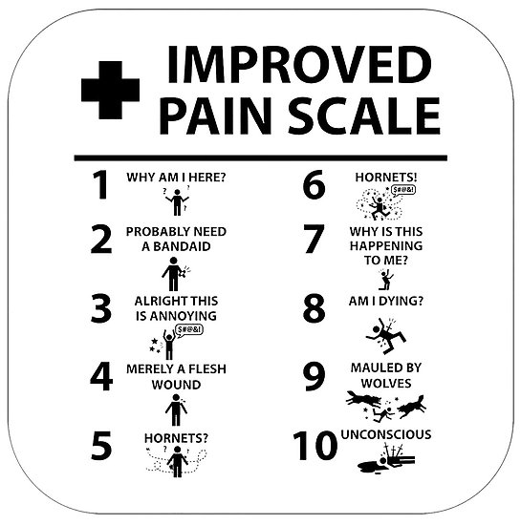

Circle problem zones on the chart:
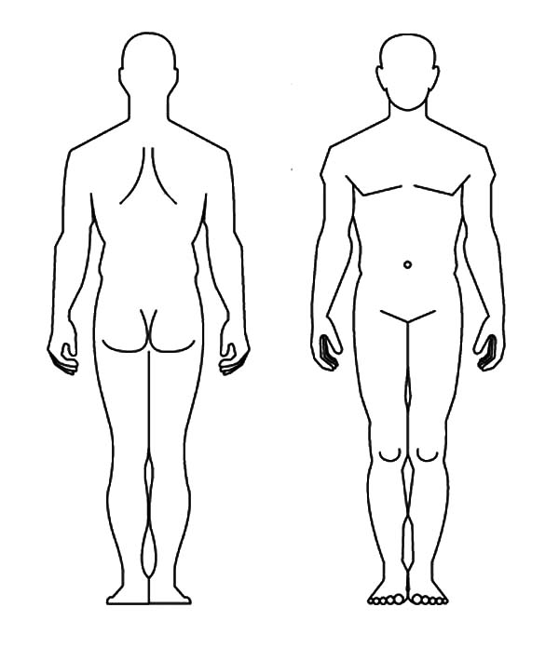
 Chest oppression  Palpitations  Coughing up blood  Pale lips  Shortness of breath when resting  Shortness of breath on exertion  Difficulty inhaling  Difficulty exhaling  Weak/Shallow breathing
PATIENT’S NAME: _____________________
 Feeling of heaviness in body  Aching in the bones  Low back pain  Knee pain  Weak legs
 Frequent urination  Difficult urination  Retention of urine  Painful urination  Blood in urine  Pale urine Dark urine Cloudy urine Copious urination  Scanty urination  Incontinence Frequent urination at night  Edema in the legs
 Hemorrhoids  Blood in stool
 Low sex drive  Excessive sexual desire
Please check off any of the following symptoms you have it.

WOMEN:  PMS  Breast distension  Vaginal discharge  Vaginal itching  Irregular periods  Late periods  Early periods  No periods  Infertility
 Heavy menstrual bleeding  Light menstrual bleeding  Leukorrhea Endometriosis
Last day of Menstrual period:____/______/_____
Menopause: Age of menopause: _____
Menopausal symptoms: _______________________________________________
Pregnancy: # of pregnancies: _____ # of births: _____ # of miscarriages: _____ # of abortions: _____ # of premature births _____
MEN:  Pain or swelling of scrotum  Impotence  Premature ejaculation
Please feel free to list/describe any other issues you would like to discuss. ______________________________________________________________________________________________________________ ______________________________________________________________________________________________________________ ______________________________________________________________________________________________________________
The information on this form is correct and accurate to the best of my knowledge.

Patient’s Signature: ___________________________________________________________________
Date Signed: / / /

